**TASK-05**

Create header and footer file inside ui.frontend component as their paths goes like ui.frontend/src/main/webpack/component inside only we need to create header and footer styling file

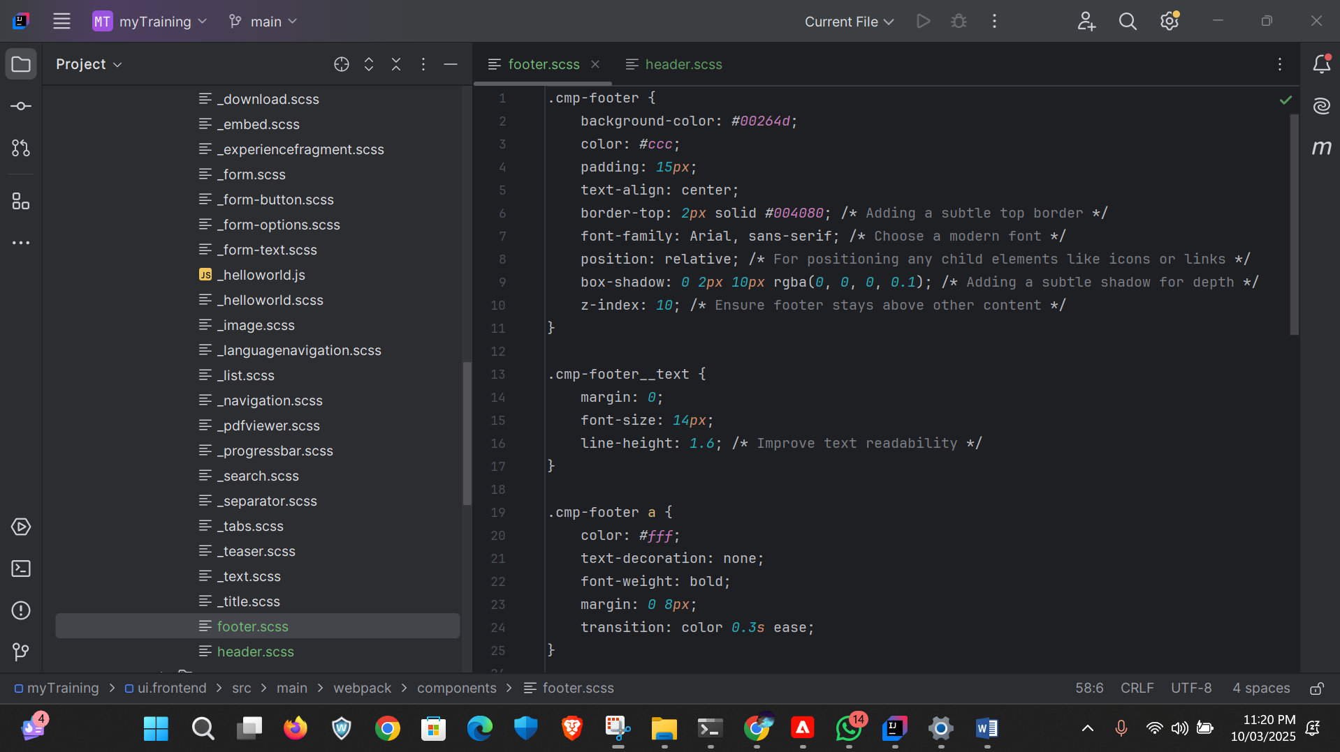

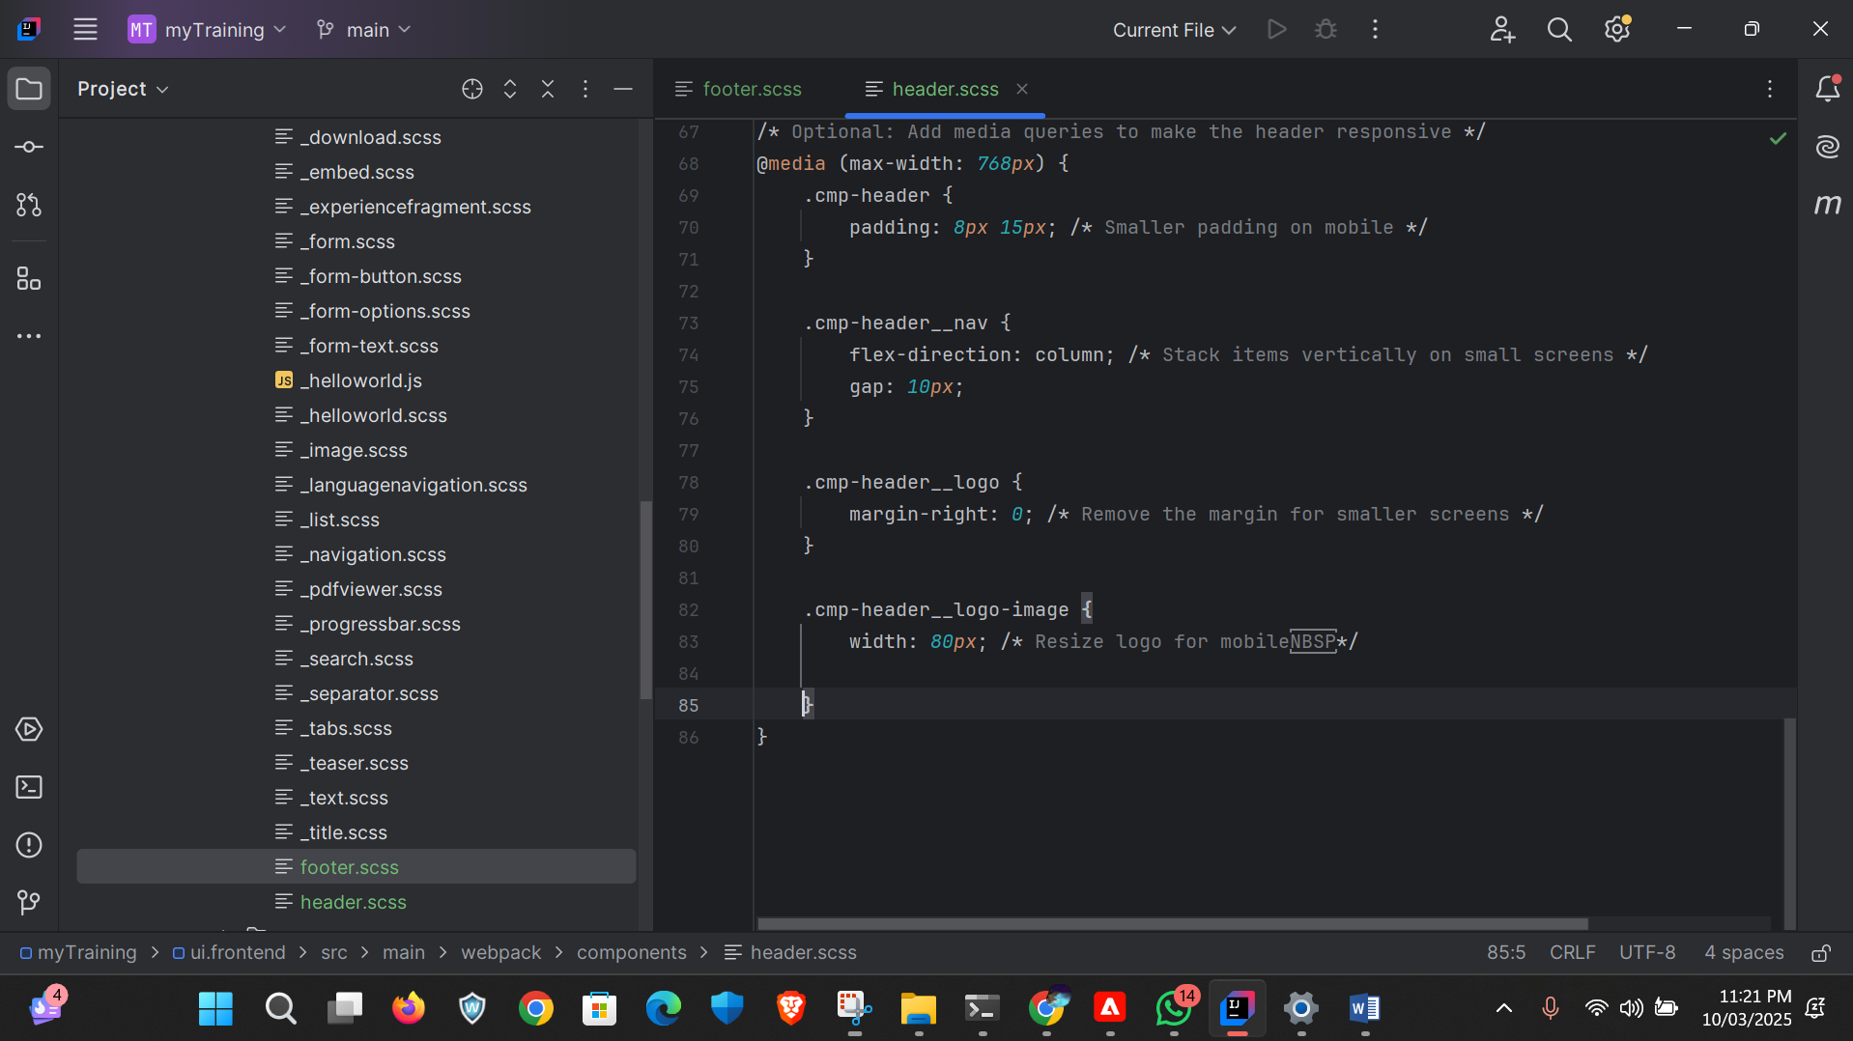

After that open aem and navigates to template we created where there is experience fragement is their and select policy and it navigate to policy page

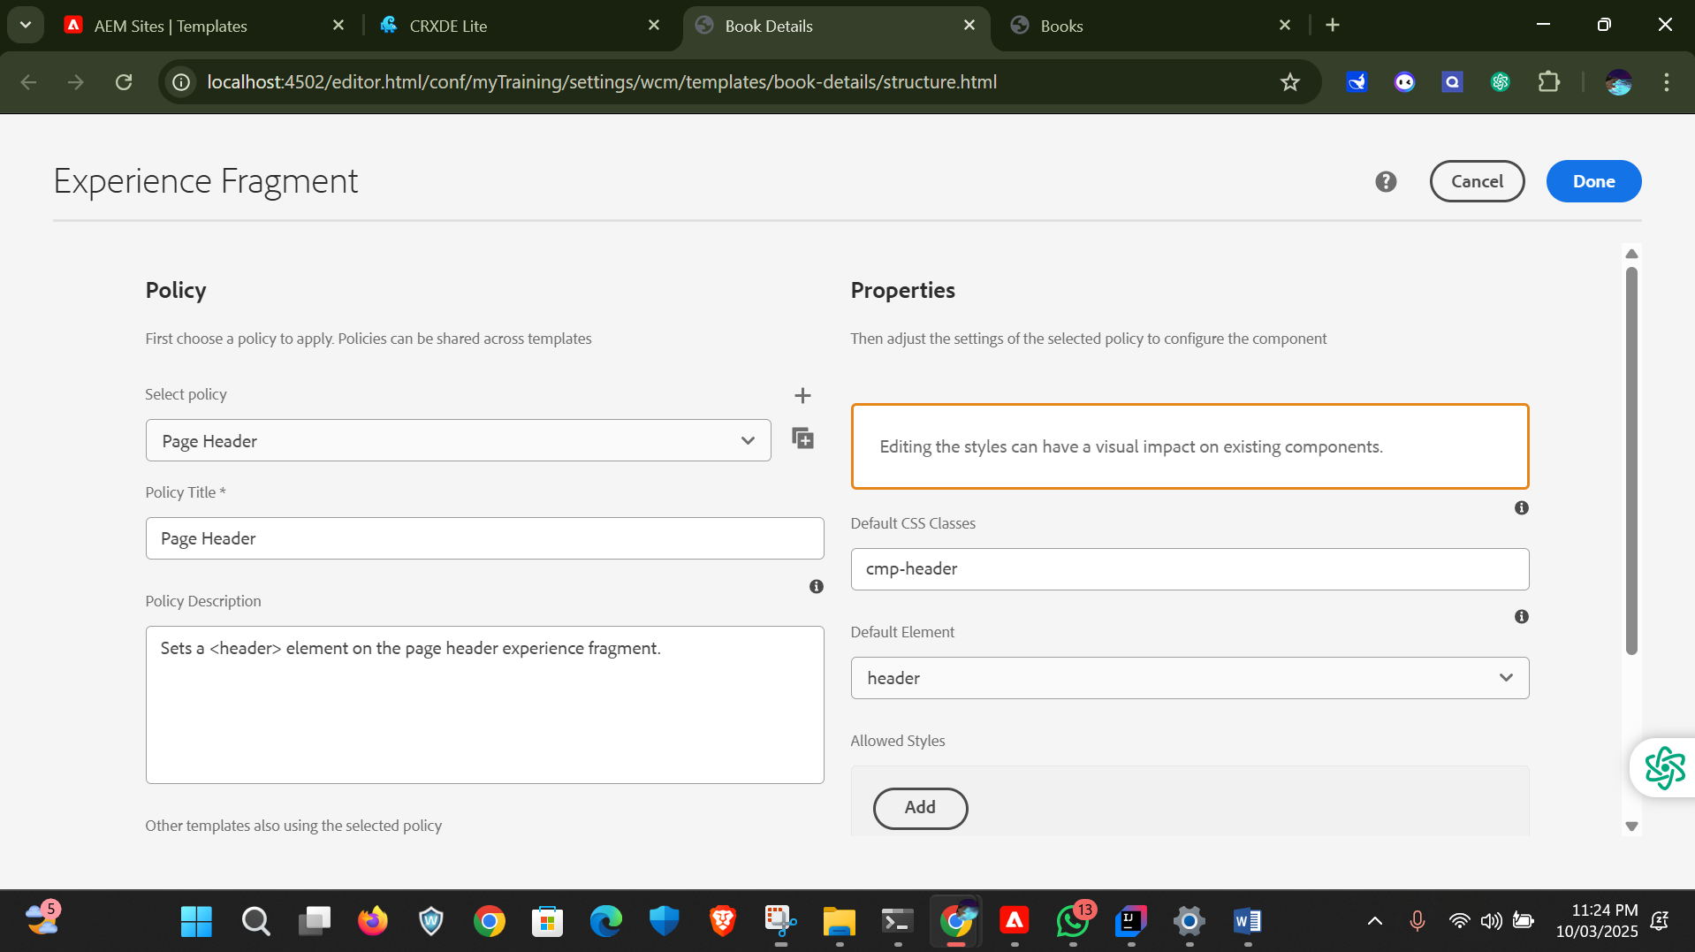

And do this same for footer

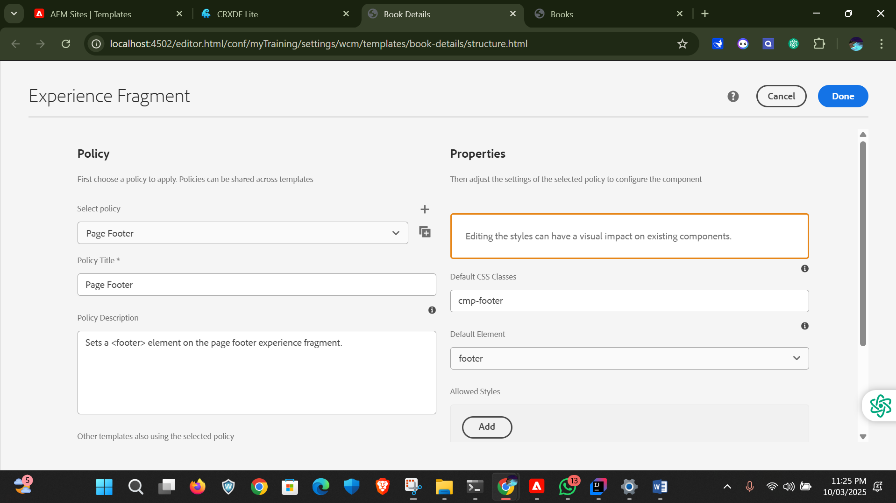After the we need to build the project and it should result in build success we need to give this command –“mvn clean install -PautoInstallPackage -Dmaven.test.skip=true”  
  
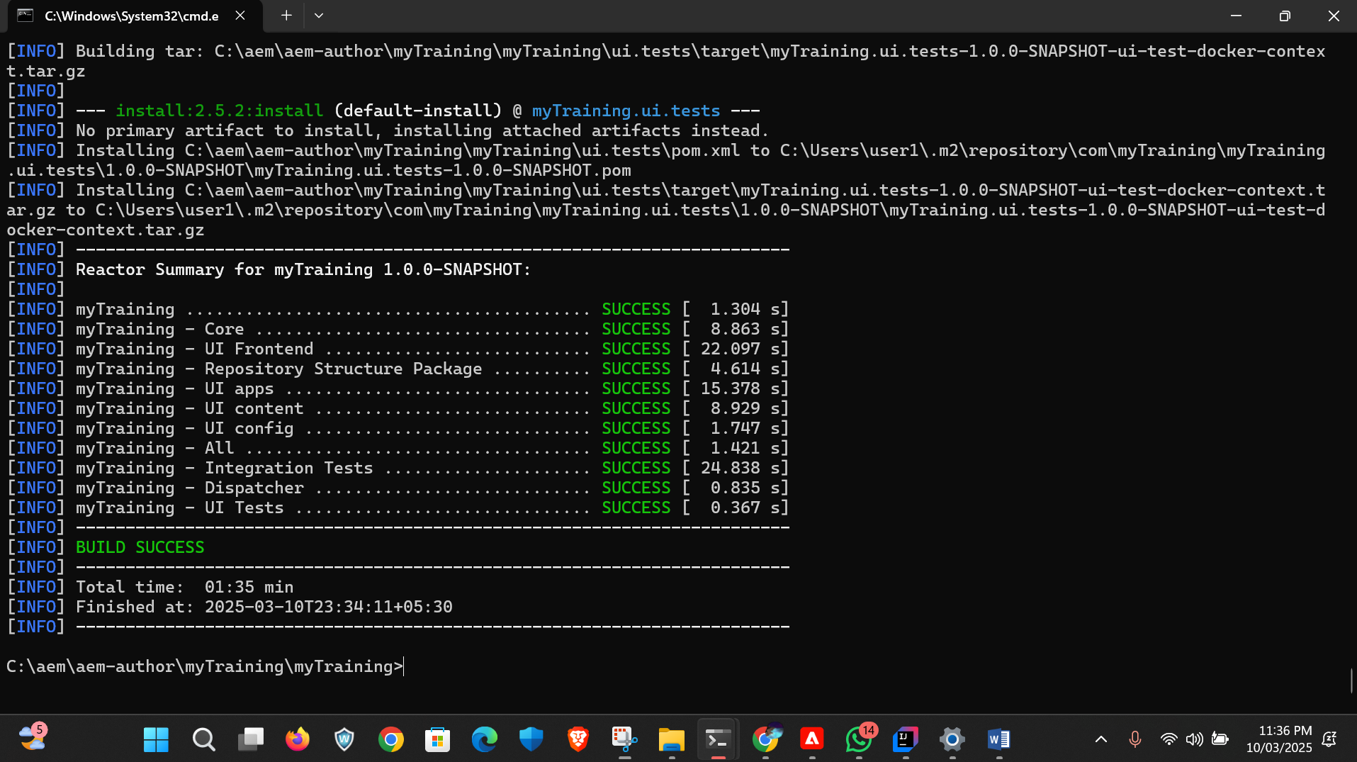

After build success we need to go our editable page and see our changes.

